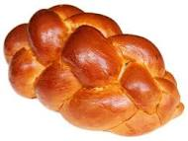
Challah Recipe

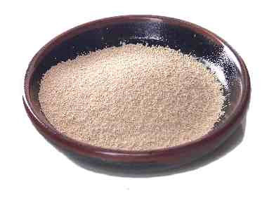
5 tsp Yeast

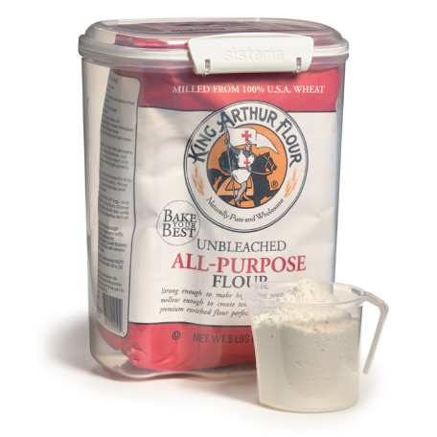
6 c Flour

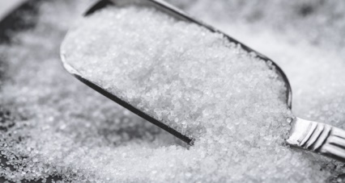
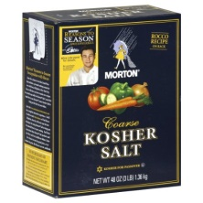
1/2 c Sugar

1 Tbsp Salt
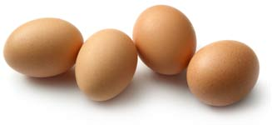

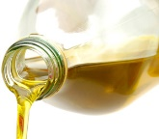
4 Large Eggs
2/3 c Oil
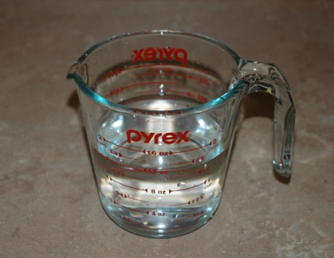

1 1/2 c Warm Water
- Combine yeast with ½ cup water and a little sugar and let bubble.
- Put dry ingredients into a bowl, make a well/hole in the middle and add wet ingredients including yeast mixture.
- Mix and knead until your hands come clean of the dough, adding up to two cups more flour if needed.
- Put flour on top of dough, cover with a clean cloth and leave in a warm place to rise until about double – 2-3 hours.
- Punch down the dough, take it out of the bowl, shape and put on a cookie sheet. (I make two challahs with this dough or up to six small challahs.) Cover with cloth and let rise another half hour.
- Baste with egg wash and bake in a preheated 350 degree oven for 30 minutes or until hollow to the tap. If you make one large challah, it will take longer to bake.

